*NETWORK SCANNING MY OWN SYSYTEM USING* **ADVANCED IP SCANNER tool**

**STEP 1:**

Open a web browser and search for **“Advanced ip scanner download**”.

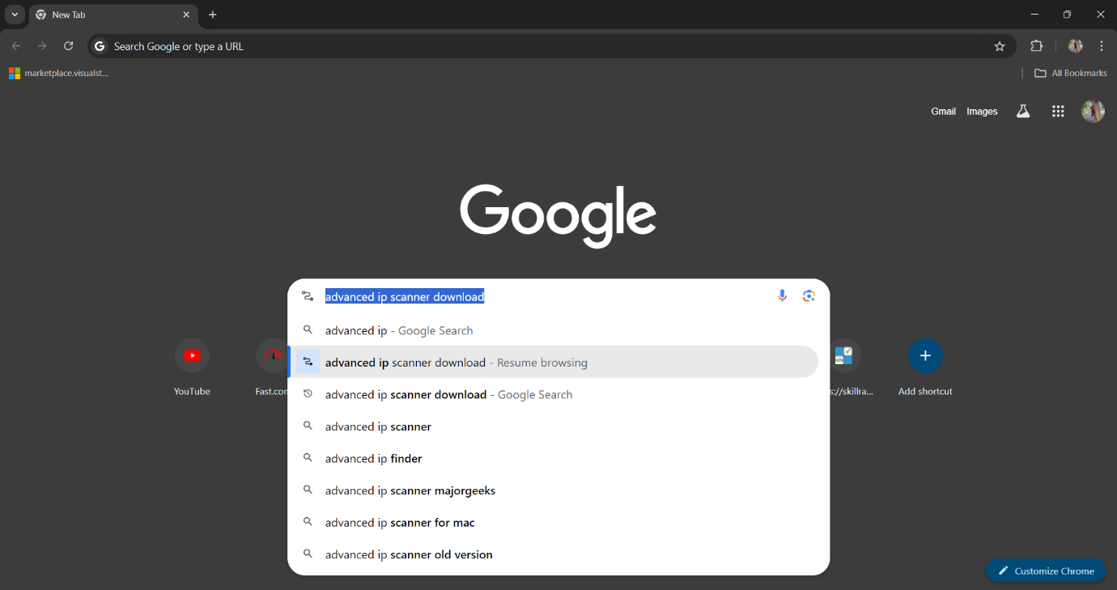

**STEP 2:**

You will see the first link in the search results; click on it.

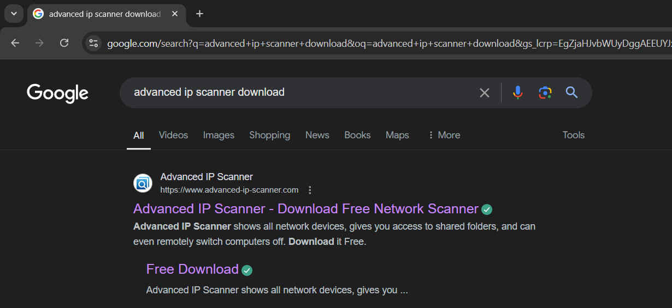

**STEP 3:**

Download the Advanced ip scanner tool according to your system's operating system, such as Windows, macOS, Linux, etc.



**STEP 4:**

To check the IP address of your system, open the command prompt and run the command: **ipconfig /all**

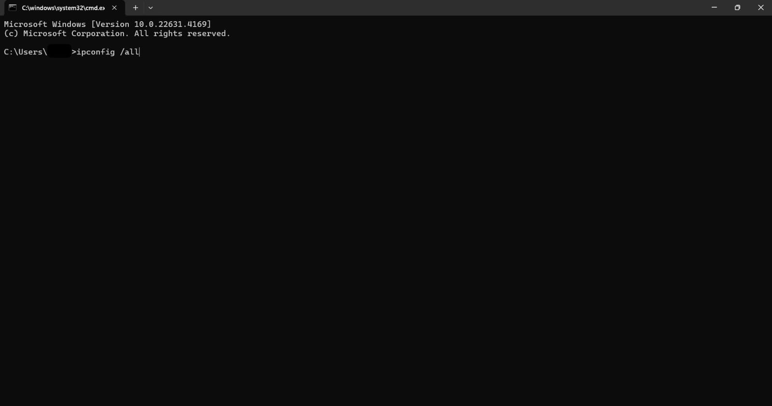

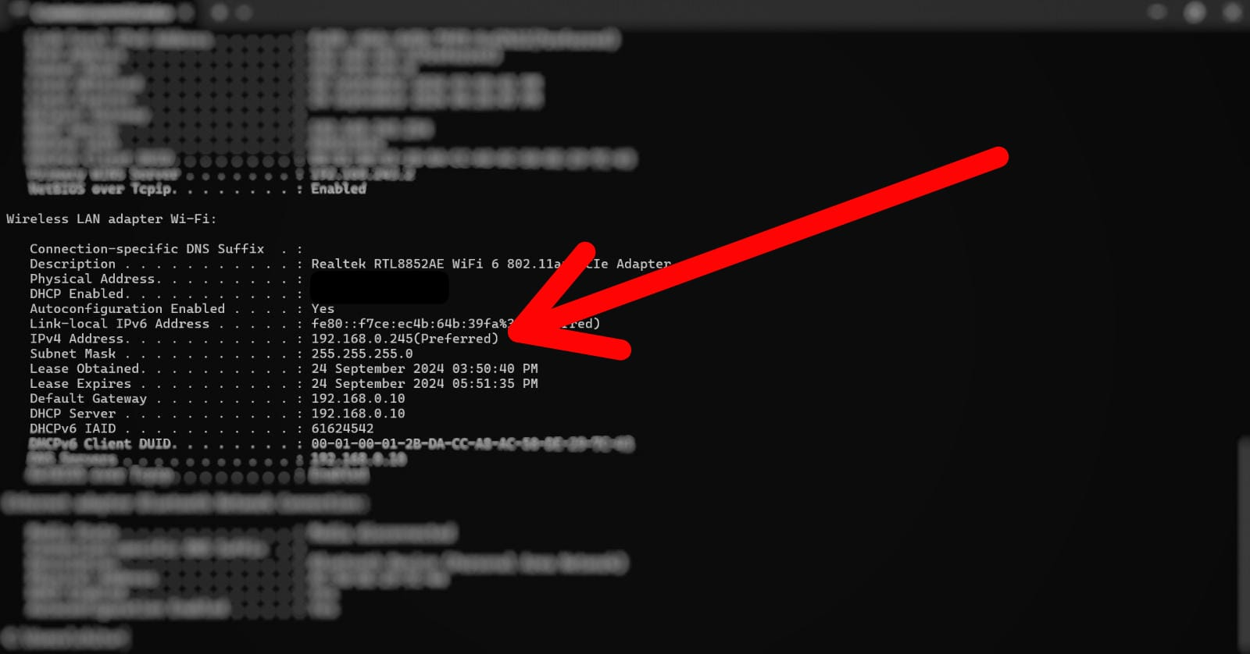

**Note:** As I am connected to the internet via Wi-Fi, I will check my IP address under the **"Wireless LAN adapter Wi-Fi"** section.

**STEP 5:**

Upon opening the Advanced IP Scanner tool, the interface displays the automatically detected IP address along with its range.

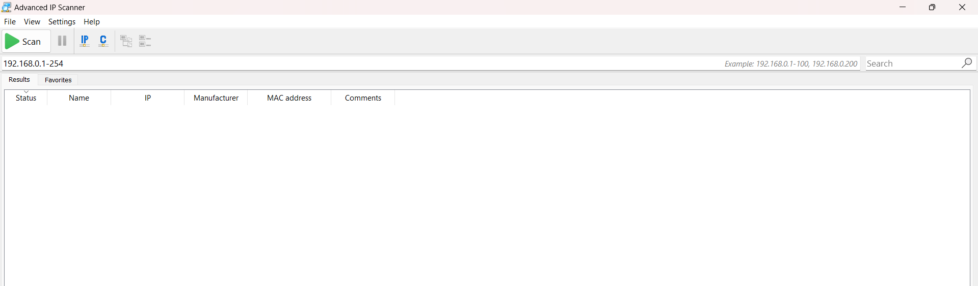

**STEP 5:**

If the IP address is not detected automatically, you can manually enter your network's IP address range by referencing the ipconfig /all output in the command prompt, then initiate the scan.

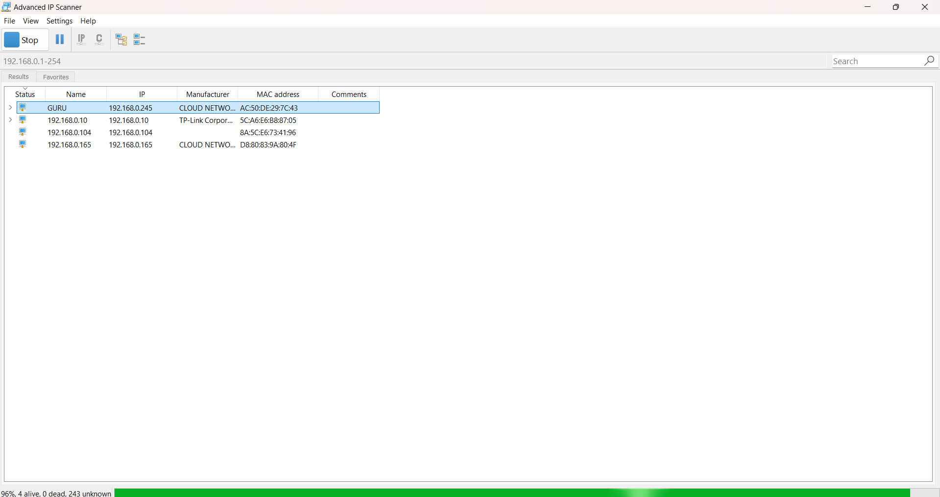

**NOTE:** The image indicates that the scan is currently in progress.

**STEP 6:**

After completing the scan, it will display the number of devices within the specified address range, along with their IP addresses, MAC addresses, and manufacturer names.

